PHASE 3: PROJECT DESIGN PHASE

System Design
The project is designed as a data migration flow in ServiceNow.

Data Flow
Excel Spreadsheet
↓
Import Set / Employee Import Table
↓
Transform Map
↓
Employee Test Table
↓
Reports
↓
Employee Analytics Dashboard

Source Table
The source table is the Employee Import table.
It temporarily stores the data loaded from the spreadsheet.

Target Table
The target table is Employee Test.
It stores the final employee records after the transformation process.

Field Mapping
The fields from the source table are mapped with the corresponding fields in the target table using Auto Map Matching Fields and Mapping Assist.
The Transform Map connects the source and target fields.

Coalesce Design
The project uses Coalesce to identify existing employee records.
The Employee ID field can be configured as Coalesce so that existing records are updated instead of creating duplicate records.

Reporting Design
Three reports are designed:
- Employees by Department – Pie Chart
- Employees by Location – Bar Chart
- Employee List Report – List format
These reports are combined into the Employee Analytics Dashboard.
Import Set Table

Navigation:
In Application Navigator → Load Data

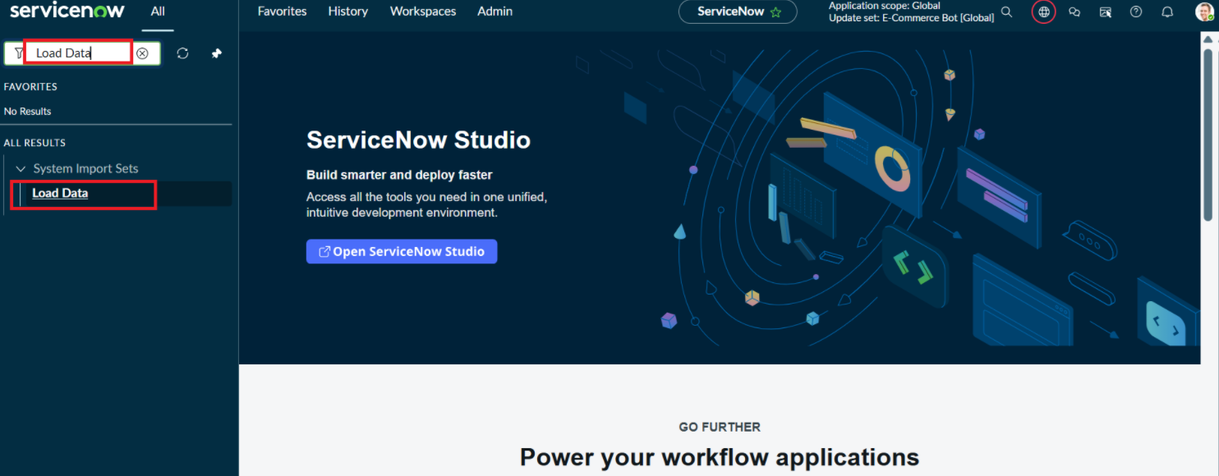
Click on Load Data and create an import table
Fill details as shown below
- Label: Employee Import
- Name: u_employee_import (auto populated)
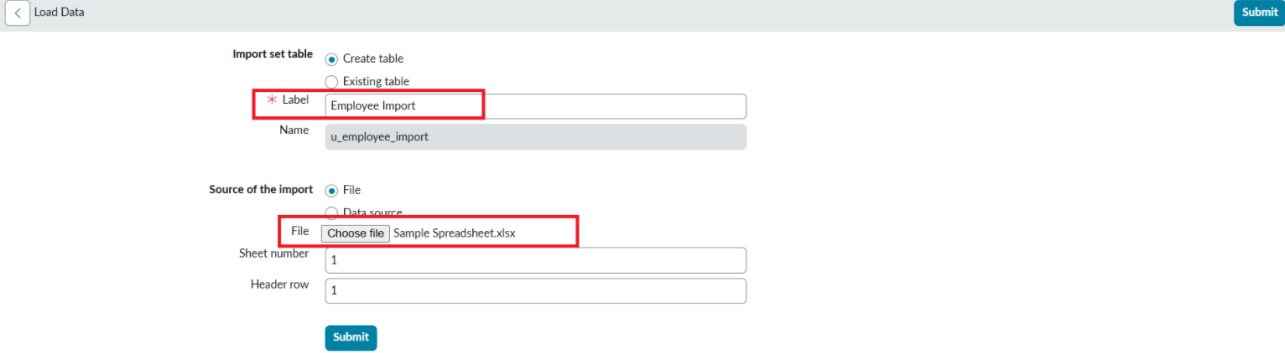

- Click on Submit
Once we click on Submit, we can see the success message as shown below.

Also we need to make sure to click on Create Transform Map.

